Day-12 Task-3: Schema design and querying on insurance claims dataset (Day-10 Task-5 dataset)
- Database creation
CREATE DATABASE DB_DAY_12_TASK_2;
USE DB_DAY_12_TASK_2;

- Schema creation (table)

CREATE TABLE InsuranceClaims(
customer_id VARCHAR(16) NOT NULL,
age INTEGER NOT NULL CHECK (age > 18),
annual_income FLOAT NOT NULL CHECK (annual_income >= 0),
insurance_type VARCHAR(32) NOT NULL,
premium_amount FLOAT NOT NULL CHECK (premium_amount >= 2000),
claim_amount FLOAT NOT NULL CHECK (claim_amount >= 0),
policy_status VARCHAR(16)
);

- Data Insertion

INSERT INTO InsuranceClaims VALUES ('C-1001', 25, 350000, 'Health', 12000, 0, 'Active');

INSERT INTO InsuranceClaims VALUES ('C-1002', 42, 850000, 'Life', 18000, 50000, 'Active');

INSERT INTO InsuranceClaims VALUES ('C-1003', 36, 620000, 'Vehicle', 15000, 22000, 'Active');

INSERT INTO InsuranceClaims VALUES ('C-1004', 55, 1100000, 'Health', 24000, 175000, 'Expired');

INSERT INTO InsuranceClaims VALUES ('C-1005', 29, 450000, 'Vehicle', 10000, 8000, 'Active');

INSERT INTO InsuranceClaims VALUES ('C-1006', 48, 950000, 'Life', 22000, 0, 'Expired');

- Grouping, Sorting and applying aggregate function
Display total claim amount of each type of insurance in ascending order

SELECT insurance_type, SUM(claim_amount) AS total_claim_amount FROM InsuranceClaims GROUP BY insurance_type ORDER BY total_claim_amount;

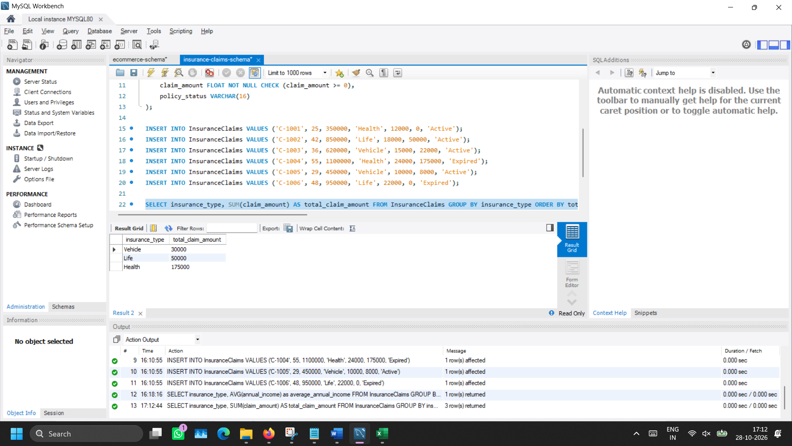

- WHERE clause usage
Retrieve insurance claims info which belongs to Vehicle insurance type.

SELECT customer_id, annual_income, premium_amount, claim_amount FROM InsuranceClaims WHERE insurance_type = 'Vehicle';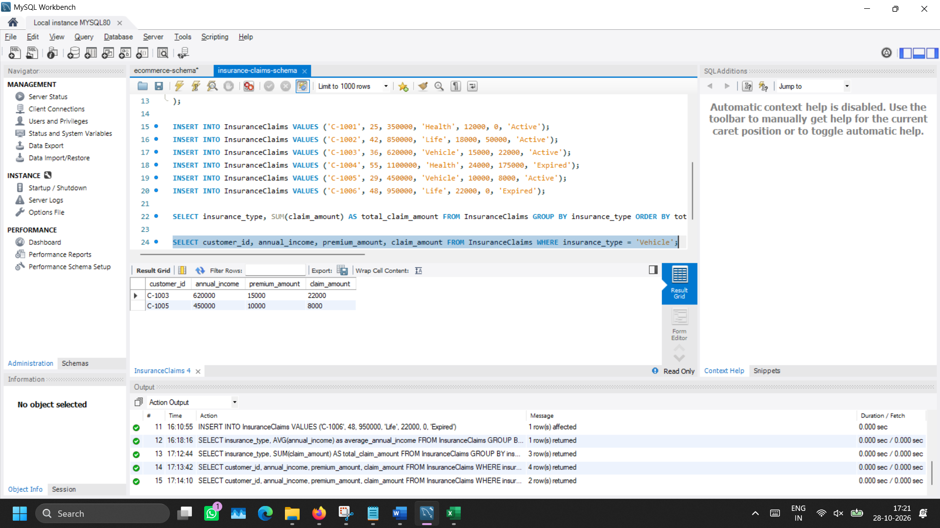
- Applying Filter
Identify all active insurance claims.

SELECT customer_id, annual_income, insurance_type FROM InsuranceClaims WHERE policy_status = 'Active';
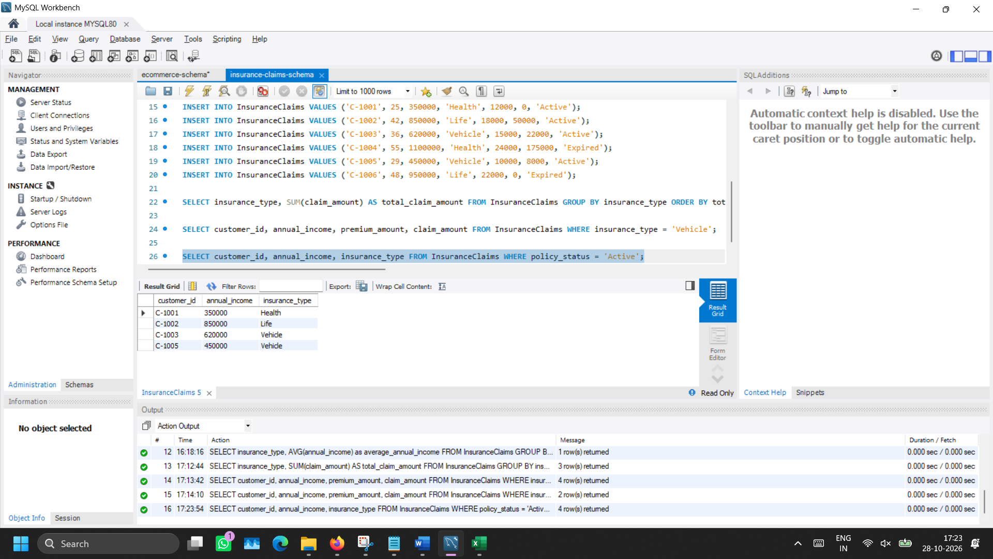

- Grouping, average and identifying top insurance type
Find the insurance type which has highest average annual income.

SELECT insurance_type, AVG(annual_income) as average_annual_income FROM InsuranceClaims GROUP BY insurance_type ORDER BY average_annual_income DESC LIMIT 1;
